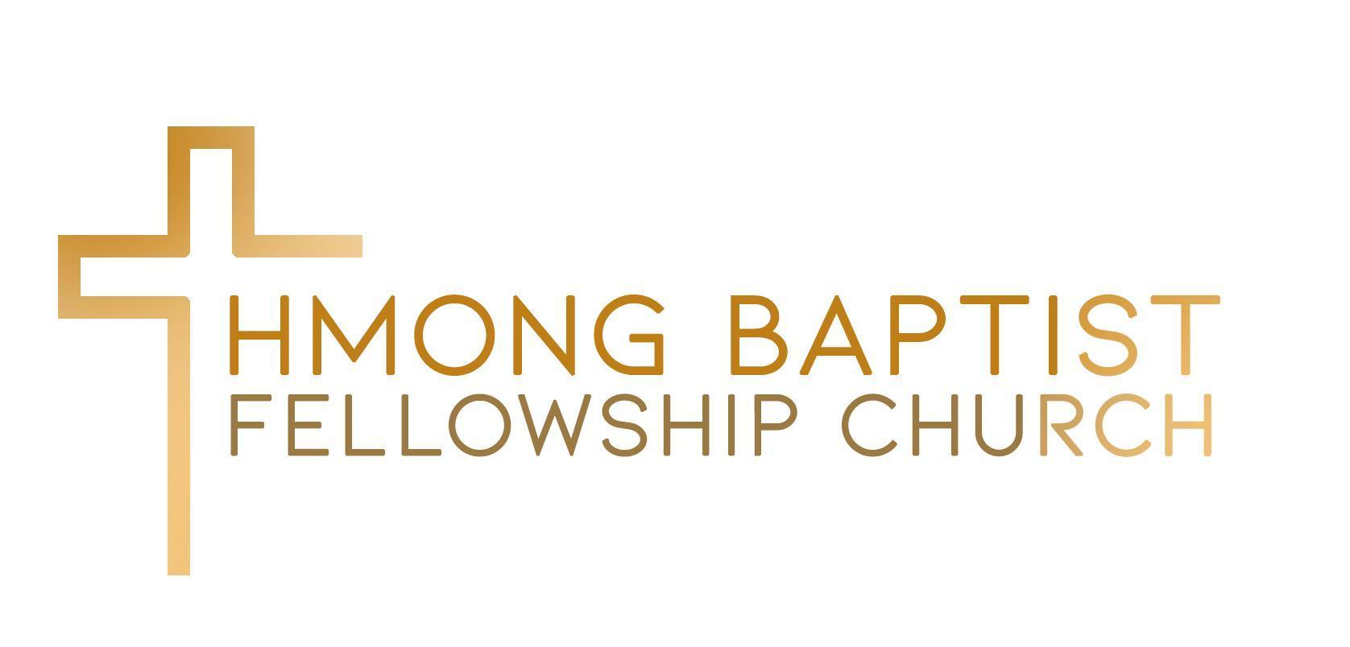

7525 Oakmont Drive
Stockton, CA 95207
(209)642-5244

Announcement for Vocational Senior Pastor Vacancy

Opening Date: March 1st, 2024 Deadline to close application: July 31, 2024

Hmong Baptist Fellowship Church is seeking a spirited filled individual to serve as the senior pastor of a small congregation. We seek a strong visionary leader who will fulfill our vision of Evangelize, Baptize and Transform through preaching the gospel of Jesus Christ, teaching sound Baptist doctrine, engaging in pastoral care ministries, and providing sound biblical training to all members of the congregation.

The Senior Pastor will provide spiritual oversight and leadership direction to church leaders and congregation. He must be an effective communicator and demonstrate the ability to preach, teach, disciple, counsel, evangelize, lead the elders, HBFC Leadership Groups, youth, and church members.

Responsibilities and Duties:

Leadership- Lead by biblical example and lifestyle, putting God first; eager to serve with humility and shepherd the congregation according to the model of a servant (1 Peter 5:2-3)

Preach/Teach- Be the primary expositor of God’s Word to the congregation. As such, he shall strive to communicate Biblical truth with excellence, providing examples of application, which the congregation can understand and integrate into daily life.

Worship- Collaborate with the worship director at HBFC as they seek together to draw the congregation into a rich worship experience.

Pastoral Care/Counseling- Offer prayer and hope to the despaired and healing to the wounded, as well as restoration to those who have distanced themselves from God.

Outreach- Lead and promote all forms of outreach opportunities to the surrounding communities and then overseas with the gospel of Jesus Christ, with various ministries and missions.

Administration- Responsible for the overall administration of the church. Interpret and direct the implementation and execution of provisions of the church Constitution and approved policies of the church.

Professional and Personal Qualifications:
- Pastoral experience and ordained required.
- Deliver biblically sound, inspirational, and spirit-filled sermons and can relate faith to the needs of children, youth, adults, and seniors. Have an outstanding interchangeable personality to positively encourage, engage, and motivate all age levels with the congregation.
- Exhibit great leadership, administrative, communication skills, can take initiative and is solution oriented.
- Must be in agreement with Baptist 2000 Faith and Message.
- Fluent in Hmong and English.
- Skilled in focused on development and growth of HBFC through promoting ministries and sustaining organizational behaviors that drive consistent spiritual engagement amongst the church. This will include supporting SBC, Delta Valley, and HBNA.
- Have a wide scope of mind, be open to feedback and suggestions from the council or HBFC for self-improvement and alignment of missions and ministries.

Salary:
Total monthly compensation is $2000.00 and after the first six months, the church council will conduct a review to reevaluate possible salary increases.

Application Process:
Interested candidates must complete the following:

- Completed Employment Application
- Statement of qualifications
- 2 Letters of recommendation

Mail application to:

Hmong Baptist Fellowship Church
Attn: Pastor Search Committee
7525 Oakmont Drive
Stockton, CA 95207

Questions and concerns may be addressed to Niam Pobzeb Yaj at hmongbaptistfellowshipchurch@gmail.com.

Candidates advancing will be contacted by the Pastoral Search Committee as to next steps of the interview process. Thank you for your interest.

Deadline to close application: July 31, 2024

