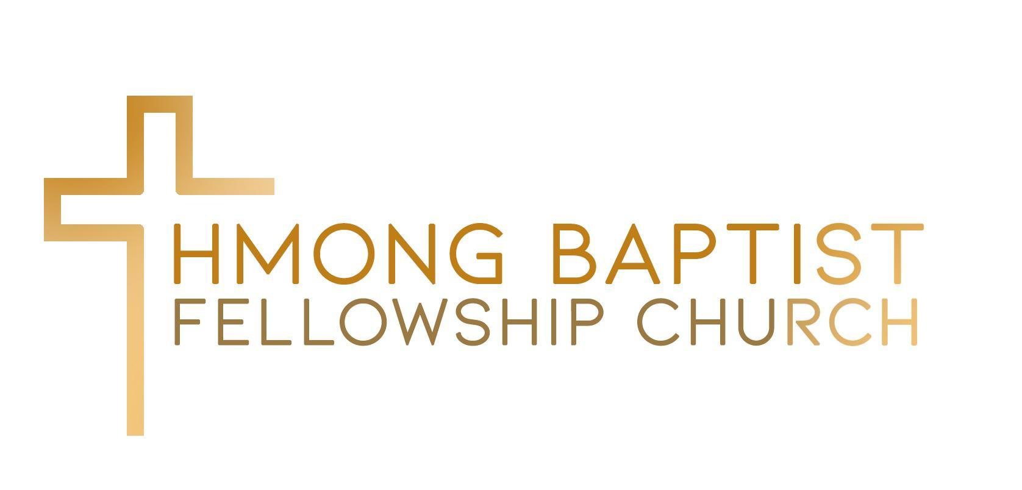

7525 Oakmont Drive
Stockton, CA 95207
(209)642-5244
Vocational Senior Pastoral Application
Date: _____/______/______
^{MM} ^{DD} ^{YYYY}

PERSONAL INFORMATION

_________________________________________________ (_____) __________________
Full Name (first, middle, last name) Home/Cell Phone Number

________________________________________________________________________________________
Address City State Zip

__________________________________________________
E-mail Address

Date of Birth: _____/______/______
^{MM} ^{DD} ^{YYYY}
Marital Status: ____________________________ If Married, number of years: ____________
If married, spouse's full maiden name: _________________________________________________________
List name(s) of dependent children:
1.
2.
3.
4.
5.
6.

Are you in possession of a pastoral license? ____ Yes _____ No
Name of licensing organization _______________________________
Have you been ordained? _____ Yes _____ No
Ordained by what organization? ____________________________
Date of Ordination: _____/______/______
^{MM} ^{DD} ^{YYYY}

Do you have any other vocational or job skills? ___________________________________________________
EDUCATION
Years completed: | Major/Degree: | Name of School:
EXPERIENCE/EMPLOYMENT
Start with Most Recent Employment: | Name of Employer: | Job Title: | Reason for leaving:
From:
To:
From:
To:
From:
To:

REFERENCES
Please provide professional names and contact phone numbers below for your references

 | Name | Contact phone number
1.
2.
3.

All candidates are subject to financial and criminal background checks. Do you authorize being subjected for a background check as required? _________Yes __________No
Please attach a family photograph.

I, hereby acknowledge that all information on this application is true and accurate.

______________________________________ __________________________________
Signature Print Name

Mail application to:

Hmong Baptist Fellowship Church
Attn: Pastor Search Committee
7525 Oakmont Drive
Stockton, CA 95207

Questions and concerns may be addressed to Niam Pobzeb Yaj at hmongbaptistfellowshipchurch@gmail.com.

Candidates advancing will be contacted by the Pastoral Search Committee as to next steps of the interview process. Thank you for your interest.

Deadline to close application: July 31, 2024

